INTD 4048/ELEC 5048
NURE 4048/NURE 5248
Art Rounds

Fall 2015
Syllabus

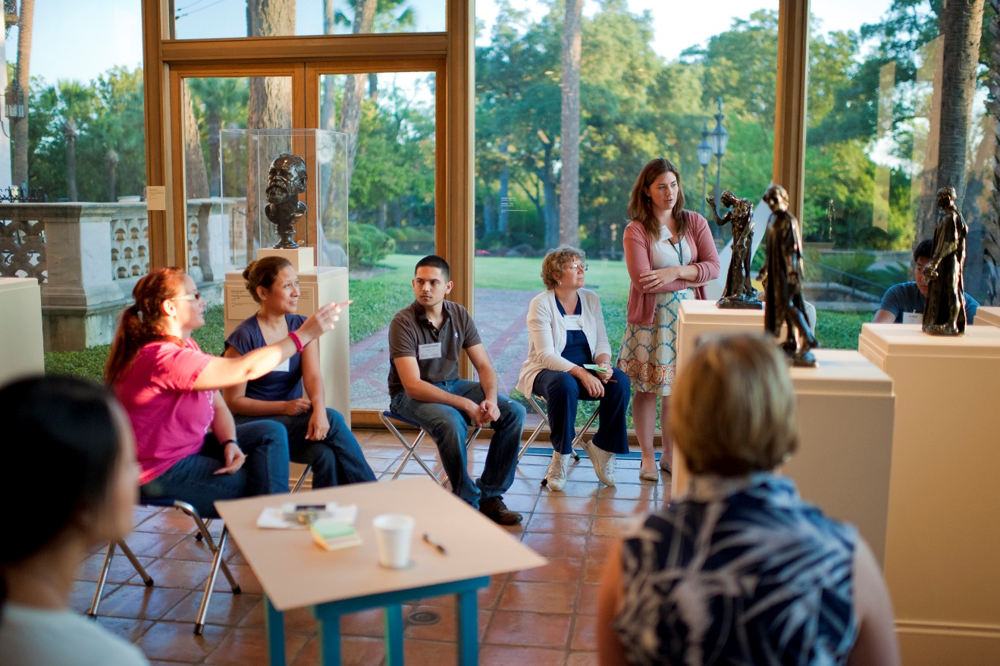

CONTACT INFORMATION
humanities@uthscsa.edu
210-567-0795
ww.texashumanities.org
ART ROUNDS

MEDICAL SCHOOL COURSE DIRECTORS
- Adam Ratner, MD, Chair and Co-Founder, Patient Institute. Clinical Professor, Radiology. 567-5558; ratnera@uthscsa.edu
- Richard Usatine, MD, Assistant Director of Humanities Education, Center for Medical Humanities & Ethics. Professor, Family and Community Medicine and Dermatology. 845-3763; usatine@uthscsa.edu

NURSING SCHOOL COURSE DIRECTOR
- Clarice Golightly-Jenkins, PhD, RN, MSN, CNS, Assistant Professor – Clinical, Department of Health Restoration & Care Systems Management, 567-5898; GolightlyJen@uthscsa.edu

SCHOOL OF ALLIED HEALTH COURSE DIRECTORS
- Mary Kay Hart, MS, BS, AAS, Assistant Professor/Clinical, Respiratory Care, 567-7963; hartmk@uthscsa.edu
- Bridgett Piernik-Yoder, PhD, MA, Associate Professor, Occupational Therapy, 567-8889; piernikyoder@uthscsa.edu

MCNAY ART MUSEUM COURSE DIRECTOR
- Kate Carey, Director of Education. 805-1764; kate.carey@mcnayart.org
- Rosemary Hickman, Museum Educator. 805-1766; rosemary.hickman@mcnayart.org
- Sheena Solitaire, Museum Educator. 805-1766; sheena.solitaire@mcnayart.org

ACADEMIC COORDINATOR
- Stephanie Gutierrez, Academic Coordinator. 567-0821; gutierrezsr@uthscsa.edu

COURSE DESCRIPTION
Art Rounds is an interactive, interprofessional course that takes students to the McNay Art Museum to learn physical observation skills. Using artwork as patients, students will learn how to observe details and how to interpret images based on available evidence. Taught jointly by UTHSCSA faculty and McNay Art Museum educators, students will view, observe, interpret, and give case reports on works of art. Studies demonstrate that these skills translate to improved patient physical observation skills.

OBJECTIVES
- Improve your visual observation skills
- Develop interprofessional communication skills
- Gain comfort with ambiguity
- Practice team-based problem solving

COURSE SCHEDULE

General Policies
- Attendance at all museum and student presentation sessions is required and cannot be made up.
- Attendance at lectures at UTHSCSA are also required but can be made up with prior excused absence
- No late assignments will be accepted unless you have made previous arrangements with the course director and your small group facilitator(s).
- Grades for this class are considered final. If you have a concern regarding a grade on any assignment, you should bring copies of the assignment in question to the Course Directors along with a written list of your concerns. The Course Directors will then have 10 days to respond to your complaint.

Readings
You are expected to complete readings assigned for a class meeting before that session meets. These readings will be discussed in the small group discussions. (Part of Attendance & Participation)

Grading
You must earn at least 80 points to pass this course.

ACTIVITY | POTENTIAL POINTS
McNay Attendance & participation | 24 (4 x 6)
Art Patient Case Blogs | 10
Portrait Differential Diagnosis | 11
Attend art education program & blog | 12
Visit another museum & blog | 12
Comment on other student’s blogs | 6
Pre & Post exams | 8 (4 + 4)
Creative Art Gallery | 8
Special Med/Art Lectures | 9 (3 x 3)
TOTAL | 100

COURSE SCHEDULE
Date/Time | Topic | Reading Due | Assignment Due
August 17 - 26  SurveyMonkey | Pre test Assignment |  | - Complete pre-test
August 27  (6-8:30p)  McNay Art Museum | Observe the Physical | - Art Rounds: Teaching Interprofessional Students Visual Thinking Strategies at One School  - Teaching Cops to See
September 10  (6-8pm)  UTHSCA  LIB 2.015 | Lecture
September 24  (6-8pm)  McNay Art  Museum | Play Well With Others | - A Brief Guide to Developmental Theory and Aesthetic Development  - One Thousand Words: Evaluating an Interdisciplinary Art Education Program | - Art Patient Reflection 1
October 7  (6-8:30p)  UTHSCSA  LIB 2.015 | Lecture
October 22  (6-8:30p)  McNay Art Museum | To Ambiguity & Beyond | - Eye diseases changed great painters’ vision of their work later in their lives  - The Real Medical Conditions behind the Deformed Hands in Rodin’s Sculptures | - Art Patient Reflection 2
November 5  (6-8:30p)  UTHSCSA  LIB 2.015 | Lecture
November 19  (6-8:30p)  McNay Art Museum | Patience with Patients | - Seven Aesthetic Habits that Improve Clinical Practice | - Differential Portrait Diagnosis Assignment  - Art Patient Reflection 3
By December 1  11:59 PM | Visit another museum |  | - Blog about an piece of art in another museum
December 2 (Wed)  6pm  UTHSCSA  Holly Auditorium Foyer | Art Gallery Presentation |  | - Creative art  - Art Patient Reflection 4
By December 8  11:59 PM  McNay Art Museum | Art education program attended |  | - Complete blog about art education program at the McNay that you attended  - Read & commented on 2 other art patient blogs
December 1-12  SurveyMonkey | Post test Assignment |  | - Complete post-test
Documents are available via Blackboard

ASSIGNMENTS
(Information on all assignments and links are available in Blackboard)

- Attendance & Participation (24 points)
  - Attendance is more than just showing up. Participation is more than just talking, it also means actively listening to others and being open-minded to new ideas and perspectives. We seek to create a safe space for conversation.
  - Participation entails (1) attendance, (2) contributing during sessions, and (3) completing the pre and post assessments.
  - Attendance is mandatory for the McNay sessions. There are no unexcused absences from this course. To make-up an excused absence for the on-campus lectures, watch the video of the presentation and write a paragraph on how the topic fits in with the course and email to gutierrezsr@uthscsa.edu.

- Pre Assessment (4 points)
  - Before the first evening of class, visit the following website and complete the pre-assessment profile. This will take 30-60 minutes.
- Art Patient (16 points = 10 blogs, 6 comments)
  - On the first evening of class, you will be paired with a student from a different discipline. Each team will randomly choose an art patient from the list given to you.
  - You should visit your patient as your team and spend a minimum of 20 minutes in observation each time you visit the McNay.
  - Art Patient Reflection Blogs
    - Blogs are due on the following dates (online):
      - Reflection 1 – September 25
      - Reflection 2 – October 30
      - Reflection 3 – November 20
      - Reflection 4 – December 3

- Medical/Art Special Lectures (9 points)
  - Over the course of the term, students will be able to attend several special lectures that explore other ways of seeing and tie art observation into medicine/nursing more directly.
  - Students are expected to attend all 3 lectures. These sessions will be recorded and can be watched online with an excused absence.
- Museum Art Education (12 points)
  - Due by December 8 at 11:59 PM (online)
  - This is an individual assignment
  - Besides the preservation of art, museums are dedicated to educating people about art and its appreciation. Over the course of the year, the McNay offers many programs and lectures on art. In this assignment, you should attend a special art education program at the McNay.
  - Write a blog entry about the lecture—who did you see, what was the title, what did they talk about, what did you learn, how did the lecture relate to the course or to the practice of nursing/medicine?

- Differential Diagnosis (11 points)
  - Due November 20 (online)
  - This is an art-patient pair assignment
  - Create a list of differential diagnoses for a piece randomly chosen from a list given. List the diagnoses in order of likelihood (most to least). For each one, explain what in the portrait suggests the subject may have the disease.
  - On a Blackboard blog, you should list your chosen portrait, share your list of differential diagnoses and reasons for each. Minimum 1,000 words.

- Visit Another Museum (12 Points)
  - Due by December 1 at 11:59 PM (online)
  - This is an individual assignment
  - You will visit another museum either in San Antonio or another city (a great activity to do with your family over Thanksgiving Holiday).
  - In that museum, find one piece of art that speaks to you
  - Write a blog about the piece of art you find, what you see in it, and why you chose it. Also discuss what the experience was like being in a different museum. How are they the same? Different?
- Creative Art (8 points)
  - Due December 3 (in-person)
  - This is an individual assignment
  - Using your art patient as your muse, create a work of art using any medium, format, or method that you wish.
  - You must include an object label for your art (artist, title, date, and brief description of the piece) and bring with your piece

- Post Assessment (4 points)
  - After the last class session, visit the following website and complete the pre-assessment profile. This will take 30-60 minutes.

ACADEMIC INTEGRITY

This course assumes that students will maintain the highest standards of honesty and integrity in their work. After all, this is an ethics class.

UT System rules require that any student who commits an act of scholastic dishonesty is subject to discipline. “Scholastic integrity includes but is not limited to cheating, plagiarism, collusion, the submission for credit of any work or materials that are attributable in whole or in part to another person, taking an examination for another person, any act designed to give unfair advantage to a student of the attempt to commit such acts” (The University of Texas System, “Rules and Regulations of the Board of Regents,” Rule 50101., p. 1).

Plagiarism is stealing the words, thoughts, ideas, organization, or data of another person without giving proper credit. Plagiarism includes taking ideas, copying words without quote marks and citations, claiming credit for work that is not your own, paraphrasing without giving credit, and using facts, statistics, graphics, etc. that is not common knowledge without giving credit and, where appropriate, quotation marks.

An assignment that has been plagiarized (in one sentence, in part, or in whole) will receive a grade of F (0) for the assignment. In addition, the case will be referred to the Dean’s office as per Board of Regents rules.

MUSEUM RULES

In order to preserve works of art and have them available for our enjoyment and the appreciation of future generations, all visitors are expected to abide by certain common courtesies.
- Art work is fragile, please help preserve them for the enjoyment of all by not touching them.
- Although the Museum Educators may invite you to get close to a piece of art, do not do so on your own. Security guards will reprimand you if you get too close a piece. Please stay at least 12 inches away.
- Use only pencils in the galleries. An accidental pencil mark is easier to remove than an accidental pen mark. Also, do not point at people or artworks with your pencil because you could injure both.
- Please do not learn on walls or cases (especially if they are supporting or displaying art).
- Museums do not permit food, drink, gum, or smoking in the galleries to protect the art.
- The McNay permits photography in the permanent galleries (but never in visiting exhibitions). Remember that your flash must always be turned off.
- Please check your coats, backpacks, large bags, and umbrellas.
- Please put cell phones and pagers on vibrate so as not to interrupt other patrons.

